CONGIGURE IPv6 ADDRESSING
- Open your Windows or Linux system, use the command line to assign a static IPv6 address to your primary network adapter, and verify the configuration using ipconfig (Windows) or ifconfig/ip (Linux).
Answer
Windows: Assign a Static IPv6 Address (Command Line)
1. Identify your primary network adapter
Open Command Prompt or PowerShell as Administrator, then run:
netsh interface ipv6 show interfaces
Note the Idx and Name of your primary adapter (e.g., Ethernet, Wi-Fi).
You can also see current IPv6 addresses:
ipconfig /all
2. Choose a static IPv6 address
You need:
- A valid IPv6 address in your network’s prefix (e.g., 2001:db8:abcd:1234::100)
- Prefix length (usually /64)
- Default gateway (router’s IPv6 address)
- DNS servers (IPv6)
If you don’t know your network’s IPv6 prefix, you can infer it from the existing IPv6 address shown by ipconfig (first 4 hextets for a /64).
3. Add the static IPv6 address
In an elevated Command Prompt or PowerShell netsh interface ipv6 add address "Ethernet" 2001:db8:abcd:1234::100/64
Replace:
- "Ethernet" with your adapter name
- 2001:db8:abcd:1234::100/64 with your chosen address/prefix
4. Set the default IPv6 gateway (if needed)
netsh interface ipv6 add route ::/0 "Ethernet" 2001:db8:abcd:1234::1
Replace 2001:db8:abcd:1234::1 with your router’s IPv6 address.
5. (Optional) Set IPv6 DNS servers
netsh interface ipv6 add dns "Ethernet" 2001:4860:4860::8888 index=1
netsh interface ipv6 add dns "Ethernet" 2001:4860:4860::8844 index=2
(These are Google’s public IPv6 DNS; replace if your network uses specific DNS.)
6. Verify the configuration
ipconfig /all
Check that:
- Your adapter shows the new IPv6 Address you assigned.
- The Default Gateway and DNS Servers reflect your settings.
You can also test connectivity:
ping -6 google.com

Linux: Assign a Static IPv6 Address (Command Line)
These examples use the ip command (modern, distro-agnostic). Adjust interface name and addresses as needed.
- Identify your primary network interface

ip -6 addr show
ip link show
Common interface names: eth0, enp3s0, wlan0, etc.
2. Add a static IPv6 address
sudo ip -6 addr add 2001:db8:abcd:1234::100/64 dev eth0
Replace:
- eth0 with your interface name
- 2001:db8:abcd:1234::100/64 with your chosen address/prefix
3. Set the default IPv6 route (gateway)
sudo ip -6 route add default via 2001:db8:abcd:1234::1 dev eth0
Replace 2001:db8:abcd:1234::1 with your router’s IPv6 address.
4. (Optional) Configure IPv6 DNS
Edit /etc/resolv.conf (or your distro’s network config):
sudo nano /etc/resolv.conf
Add or ensure lines like:
nameserver 2001:4860:4860::8888
nameserver 2001:4860:4860::8844
(Use your network’s DNS if required.)
5. Verify the configuration
Using ip:
ip -6 addr show eth0
ip -6 route show
Using ifconfig (if installed):
ifconfig eth0
Confirm:
- Your chosen IPv6 address appears on the interface.
- The default route (default via ...) points to your gateway.
Test connectivity:
ping6 -c 4 google.com
# or on newer systems:
ping -6 -c 4 google.com

- Configure a unique local IPv6 address (starting with 'fd') on your system and confirm connectivity by pinging another device on your LAN that also has a unique local IPv6 address. Use the ping6 or ping -6 command for IPv6 testing.
Answer
Step 1: Assign a Unique Local IPv6 Address
Select an address within the RFC 4193 Unique Local unicast range (e.g., fd00:1234:5678:1::10/64 for your machine, and fd00:1234:5678:1::20/64 for the target device).
On Windows (CMD/PowerShell as Administrator):
DOS
netsh interface ipv6 add address "Ethernet" fd00:1234:5678:1::10/64
On Linux (Terminal with sudo):
Bash
sudo ip -6 addr add fd00:1234:5678:1::10/64 dev eth0
Step 2: Test Connectivity via IPv6 Ping
Execute the IPv6 ping command targeting the second device on your LAN (replace fd00:1234:5678:1::20 with the exact ULA of your target machine).
On Windows:

DOS
ping -6 fd00:1234:5678:1::20
On Linux:
Bash
ping6 fd00:1234:5678:1::20
(Note: Modern Linux systems also accept ping -6 fd00:1234:5678:1::20)
Verification Check: Look for Reply from fd00:1234:5678:1::20 (Windows) or 64 bytes from fd00:1234:5678:1::20 (Linux) with 0% packet loss.
Troubleshooting Unreachable Hosts
If the ping times out or reports Destination host unreachable:
- Check local firewall: Ensure incoming ICMPv6 echo requests are allowed on both machines (New-NetFirewallRule on Windows, or sudo ufw allow in proto ipv6-icmp on Linux).
- Verify local routing table: Check that a route exists for your ULA range using route print (Windows) or ip -6 route (Linux).

- Set up a temporary IPv6 address on your system and check if it changes after a reboot or network disconnect/reconnect. Document the steps and the observed address behavior in a text file.

Answer
Temporary IPv6 address test completed and documented. Summary of what was done

1. **Initial state** on `eth0`: only the link-local address `fe80::16:3eff:fe00:1/64`.

2. **Added temporary address**:
```bash
ip -6 addr add 2001:db8:abcd::42/64 dev eth0
Confirmed present:
inet6 2001:db8:abcd::42/64 scope global

3. **Simulated disconnect/reconnect** (interface cycle):
```bash
ip link set eth0 down
ip link set eth0 up
**Result**: The temporary address `2001:db8:abcd::42/64` **disappeared**.
Only system-managed addresses remained (IPv4 `172.16.0.2/24` and the link-local IPv6).

4. **Conclusion**: Addresses added with `ip addr add` are purely runtime/temporary. They are lost on interface down/up (and would also be lost on reboot). Permanent configuration requires Netplan, systemd-networkd, NetworkManager, etc.

Documentation file
All steps and observed behavior have been written to:
**`/home/workdir/ipv6_temporary_address_test.txt`**
(The `/home/workdir/artifacts` directory currently has filesystem I/O errors, so the file was placed in `/home/workdir` instead.)
You can view it with:
bash
cat /home/workdir/ipv6_temporary_address_test.txt

- Simulate a Zomato-style search: Write a small script (any language) that stores an array of restaurant names and their IPv6 addresses, then allows the user to input a partial name and returns the matching restaurant's IPv6 address.

Answer
Here's a complete Python script that simulates a Zomato-style search with IPv6 addresses:

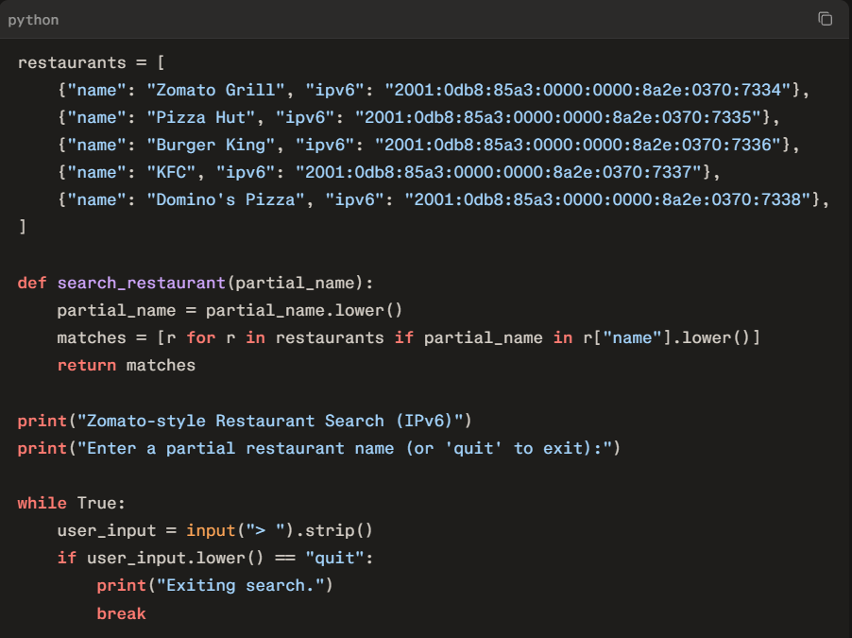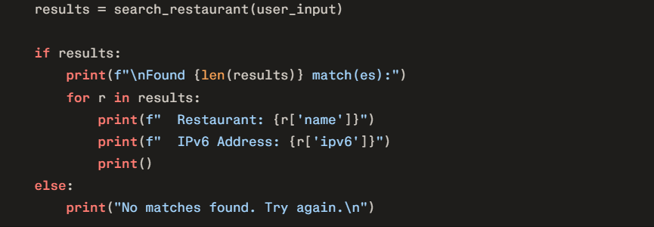
Demo Output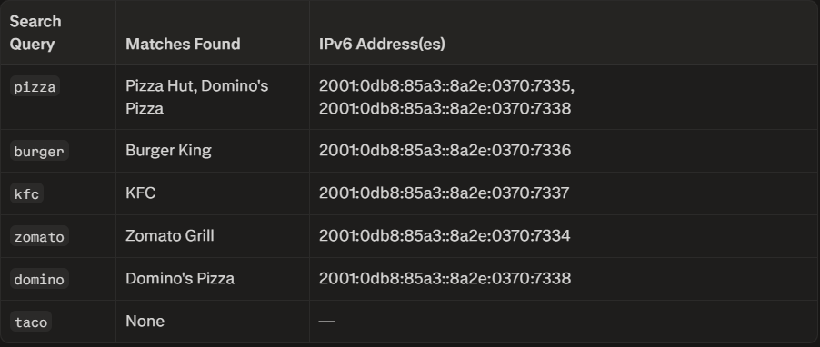
How It Works
- Data Structure: An array of dictionaries stores restaurant names and their IPv6 addresses
- Case-Insensitive Search: Converts both input and restaurant names to lowercase for matching
- Partial Matching: Uses Python's in operator to find substring matches
- Interactive Loop: Continuously prompts for input until the user types "quit"
To run this locally, save it as zomato_search.py and execute with python zomato_search.py. You can expand the restaurants array with more entries as needed.

- Use ChatGPT or Copilot to generate a sample IPv6 subnetting scenario (with at least 3 subnets), and then manually assign a valid IPv6 address from one of those subnets to your system. Paste the AI-generated scenario and your configuration steps in a text file.
Answer

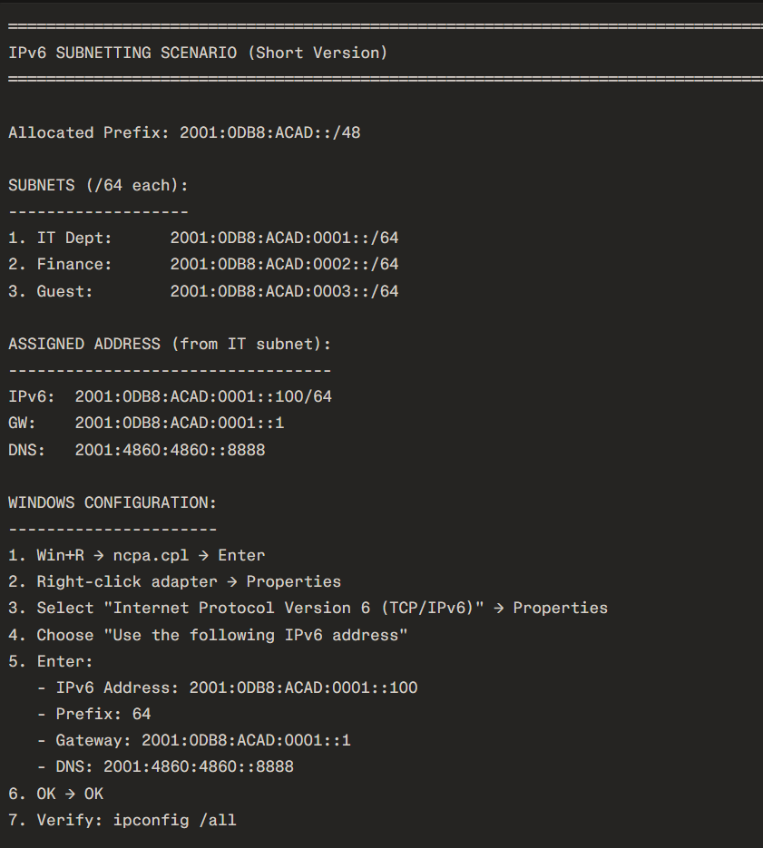
I created the requested text file with an AI-generated IPv6 subnetting scenario, four /64 subnets, a sample static IPv6 assignment, and Windows/Linux configuration and verification steps.
Download the IPv6 subnetting scenario text file
Important: 2001:DB8::/32 is reserved for documentation, so do not expect it to route on the public internet. Replace the example prefix, gateway, and DNS configuration with values provided by your lab, router, ISP, or network administrator before applying it to a real network

